**NEWCASTLE BUSINESS SCHOOL**

*The University of Newcastle, NSW, Australia*

Course code: BUSA 3002

Course name: Business Intelligence & Data Management

Assignment 2 Report

**Transforming Starbucks’ CRM with Business Intelligence: Data-Driven Strategies for Personalisation, Efficiency, and Growth**

|  |  |  |
| --- | --- | --- |
| **Student number** | **Name** | **Date** |
| **C3425175** | **Tan Thuy Linh Dao** | **18th-May-2025** |

**Word count: 3400 words**

TABLE OF CONTENTS

1. INTRODUCTION 5

1.1. The Data-Driven Imperative in Modern Business 5

1.2. The CRM Challenge in the Digital Age 5

1.3. Starbucks: A Case Study in CRM Transformation 5

2. EXISTING ISSUES IN ERP SYSTEM 5

2.1. Some Definitions 5

2.1.1. Business Intelligence (BI) 5

2.1.2. Enterprise Resource Planning 5

2.1.3. Customer Relationship Management (CRM) 6

2.2. Existing issues for the CRM in the traditional industry without the power of BI 6

2.2.1. Limited Real-Time Customer Insights 6

2.2.2. Poor Personalisation & Marketing Effectiveness 6

2.2.3. Lack of Predictive Forecasting 6

2.2.4. Weak Customer Retention Analysis 7

2.3. Case Study: Starbucks CRM Issues 7

3. BI REQUIREMENTS 9

3.1. BI requirements for CRM within ERP 9

3.1.1. Data Sources and Integration Challenges 10

3.1.2. ETL Process and Real-Time Data Handling 10

3.1.3. Storage Layer: Enterprise Data Warehousing and OLAP 10

3.1.4. Processing Layer: Analytics and Real-Time Compute 10

3.1.5. Application Layer: Visualisation and CRM UI 10

3.2. Starbucks and CRM – Specific BI requirements 10

3.2.1. Customer Segmentation & Personalisation 10

3.2.2. AI-Driven Product Recommendations 11

3.2.3. Demand Forecasting & Inventory Optimisation 11

3.2.4. Customer Retention & Churn Prevention 11

4. PROPOSED BI SOLUTION 11

4.1. Customer segmentation & Personalisation 11

4.2. AI-Driven Product Recommendation 12

4.3. Demand Forecasting & Inventory Optimisation 12

4.4. Customer Retention & Churn Prevention 12

5. DATA DASHBOARD 12

5.1. Customer Segmentation & Personalisation 12

5.2. AI-Driven Product Recommendation 13

5.3. Customer Retention & Churn Analysis 14

6. DISCUSSION AND CONCLUSION 15

6.1. The ethical considerations 15

6.1.1. Data Privacy & Consent 15

6.1.2. Algorithm Bias & Fairness 15

6.1.3. Environmental Sustainability 15

6.2. The design principles behind an efficient data dashboard 16

6.3. Conclusion – Main point from the report 16

7. APPENDIX 17

8. REFERENCE 18

**TABLE OF FIGURE**

Figure 1. ERP Modules (Themistocleous et al, 2005) 6

Figure 2. Starbucks' Operation Performance in 2008 (Schultz, 2008) 7

Figure 3. Starbucks' Store Sales in 2008 (Schultz, 2008) 8

Figure 4. Starbucks' Net Earnings (Schultz, 2008) 8

Figure 5. Typical business intelligence architecture. Note (Chaudhuri et al, 2011) 9

Figure 6. Data Warehousing Architecture. Note (Chaudhuri & Dayal, 1997) 9

Figure 7. BI's architecture requirements for CRM (Author’s work) 9

Figure 8. Starbucks Customer Segmentation Dashboard (Author’s work) 13

Figure 9. Starbucks' AI Product Recommendation Dashboard (Author’s work) 14

Figure 10. Starbucks' Customer Retention & Churn Analysis (Author’s work) 15

**TABLE OF TABLE**

Table 1. Competition in the Australian specialty coffee chain market (Patterson et al, 2010) 8

# **INTRODUCTION**

## **The Data-Driven Imperative in Modern Business**

In today's hypercompetitive digital economy, information has become the most valuable organisational asset. The modern business landscape faces an unprecedented paradox: although data availability has grown exponentially, gaining meaningful insights from this deluge of information presents significant cognitive and technological challenges. Human decision-makers are constrained by natural limitations in processing capacity, while simultaneously dealing with information noise - redundant, contradictory, or low-quality data that obscures actionable intelligence. This environment has elevated Business Intelligence (BI) systems from optional tools to strategic necessities, transforming them into the central nervous system of data-driven organisations (Habul & Pilav-Velic, 2010).

## **The CRM Challenge in the Digital Age**

Contemporary enterprises face a fundamental operational challenge: delivering precisely contextualised information through all customer touchpoints. In an era of multichannel commerce, successful customer relationship management (CRM) relies on consistent, personalized communication across digital platforms, physical locations, and hybrid interfaces. Traditional CRM systems, however, often fail to integrate these multidimensional interactions into coherent strategies. This gap between data availability and operational application generates critical vulnerabilities in customer retention, satisfaction, and lifetime value optimisation - weaknesses that become particularly during market contractions or competitive threats (Habul & Pilav-Velic, 2010).

## **Starbucks: A Case Study in CRM Transformation**

This report examines Starbucks' 2008 financial downturn—a case study in CRM failures caused by ineffective data utilisation—as the foundation for proposing BI-driven solutions to address the company's challenges of declining revenues and widespread store closures, which were exacerbated by an inability to effectively harness customer data for retention and demand forecasting. The analysis will demonstrate the transformative value of BI integration in enhancing CRM capabilities through real-time customer insights, AI-driven personalisation, and predictive churn prevention, while outlining an effective BI strategy that emphasises key architectural components (data warehouses and ML models), ethical data governance, and dashboard-driven decision support. Ultimately, the report proposes a comprehensive BI-augmented CRM architecture designed to restore Starbucks' competitive edge, including solutions that are scalable and transferrable to broader industries suffering similar data utilisation challenges in their customer relationship management systems.

# **EXISTING ISSUES IN ERP SYSTEM**

## **Some Definitions**

### Business Intelligence (BI)

Business intelligence (BI) is a broad term that encompasses architectures, tools, databases, analytical tools, applications, and methodologies. BI’s major objective is to enable interactive access (sometimes in real time) to data, data modification, and the ability for business managers and analysts to conduct appropriate analysis (Turban, 2008)

### Enterprise Resource Planning

ERP is an application that automates business processes and provides insights into internal controls, drawing on a central database that collects inputs from departments, including accounting, supply chain management, sales and human resources (HR), etc.. ERP is not a standalone application. While ERP is a category of business software(McCue, 2023), ERP systems generally comprise various software modules, which allow organisations to automate and integrate the majority of business functions by accessing and sharing common information, data, and practices across the enterprise in real-time. A defining feature of an ERP system is the integration of different organisational functions, so that information is entered only once, and is thereafter available across the organisation with real-time updates (Ali & Miller, 2017)

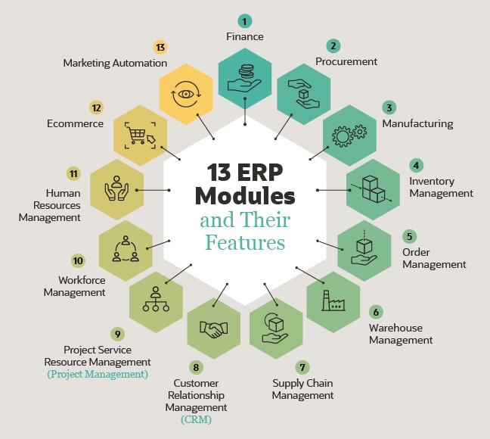

Figure 1. ERP Modules (Themistocleous et al, 2005)

### Customer Relationship Management (CRM)

CRM (customer relationship management) is one of the modules within the ERP system. It is an approach that combines the use of an efficient management system (technology) and a customer-oriented approach (customer-focused processes) (Sardjono et al, 2023) to manage and analyse customer interactions and data across the customer lifecycle. The purpose is to improve customer service relationships, develop long-term customer relationships (Sardjono et al, 2023), assist customer retention and increase business profit (Barney et al., 2023)

## **Existing issues for the CRM in the traditional industry without the power of BI**

Traditional customer relationship management (CRM) systems in non-digitised industries focus on managing customer interactions and building relationships through manual processes and less sophisticated data analysis. This means relying on spreadsheets, email logs, and static reports to track customer data and sales activities. While still valuable, this approach lacks the advanced insights and predictive capabilities that BI offers, leading to less personalised experiences and potentially hindering the capability to optimise customer interactions and strategies

### Limited Real-Time Customer Insights

Traditional CRMs cannot analyse or update customer data in real time, forcing sales teams to manually input and manage records, which is time-consuming and error-prone (Tucker, 2024). Unlike modern cloud-based CRMs that integrate with social media, AI tools, and third-party apps, legacy systems operate in isolation (Gulbinovic, 2015)

### Poor Personalisation & Marketing Effectiveness

Conventional CRM systems depend on historical data rather than predictive analytics, limiting their ability to personalise marketing efforts. These systems are reactive, focusing on past customer interactions rather than forecasting future behaviours or preferences (Leapify, 2024). Without AI-driven segmentation, businesses struggle to deliver personalised experiences, leading to lower engagement and conversion rates

### Lack of Predictive Forecasting

A critical drawback of traditional CRM is its inability to foresee demand fluctuations. Without BI-powered forecasting, businesses face challenges in inventory management, resulting in stockouts during peak demand or excess inventory during slow periods (Subham Kumar R, 2023). This limitation impacts supply chain efficiency and customer satisfaction.

### Weak Customer Retention Analysis

Legacy CRM systems lack sophisticated churn prediction models, making it difficult to identify at-risk customers or measure loyalty program effectiveness. Without automated retention triggers, businesses miss opportunities to re-engage customers before they defect to competitors

## **Case Study: Starbucks CRM Issues**

Starbucks, founded in 1971 at Seattle's Pike Place Market, grew from a single coffee shop into a global phenomenon. By the early 2000s, the company had established a presence across all 50 U.S. states and 43 countries, achieving an extraordinary growth rate of opening approximately one new store per day during its peak expansion years (Patterson et al, 2010). This rapid growth earned Starbucks numerous accolades, including "Best Business" and "Most Admired Company" awards (Husain et al., 2014), strengthening its reputation as a premium coffee brand.

However, this rapid expansion came at a cost to customer relationships. The company's traditional CRM systems failed to scale with its growth, leading to three critical failures. First, the personalised customer experience that built Starbucks' early success became diluted across thousands of locations. Customers began noticing inconsistent service quality, with some stores failing to meet the company's high standards. Second, Starbucks lacked effective systems for gathering and responding to customer feedback in real-time, creating a growing disconnect between corporate decisions and customer expectations. Third, the corporation failed to properly track shifting customer preferences and emerging competitive threats (*Starbucks’ Customer Management Case Study - GWO SEVO*, 2024).

These CRM weaknesses left Starbucks vulnerable when the 2008 financial crisis hit. As consumers became more price-sensitive (Maverick, 2024), competitors like Dunkin' Donuts and McCafé capitalised with cheaper alternatives (Patterson et al, 2010). Starbucks' outdated systems couldn't anticipate or quickly respond to these market changes, resulting in 600 store closures in 2008, a 28% profit decline, followed by another 300 closures and 6,700 layoffs in 2009 (Husain et al., 2014).

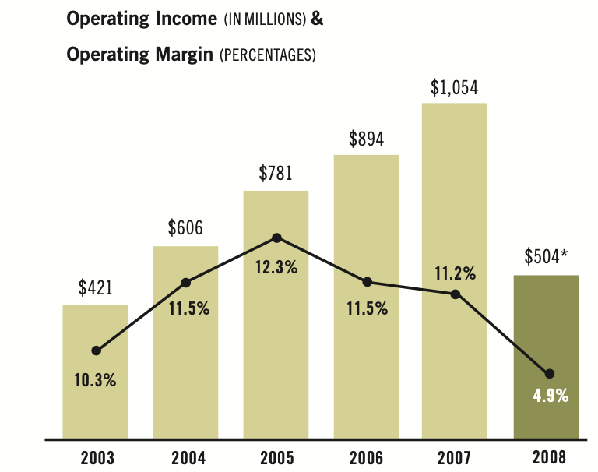

Figure 2. Starbucks' Operation Performance in 2008 (Schultz, 2008)

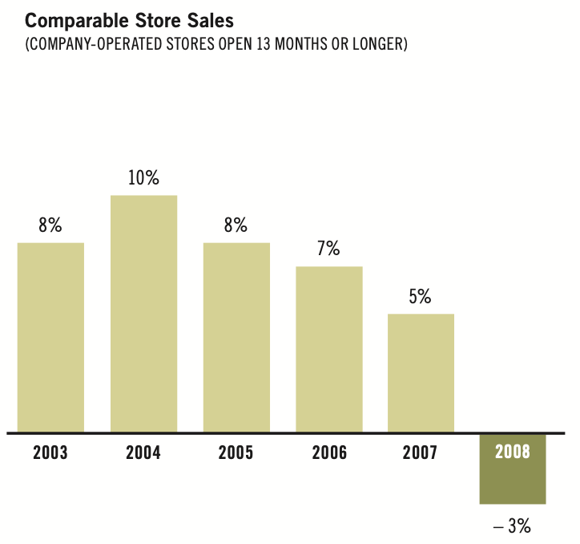

Figure 3. Starbucks' Store Sales in 2008 (Schultz, 2008)

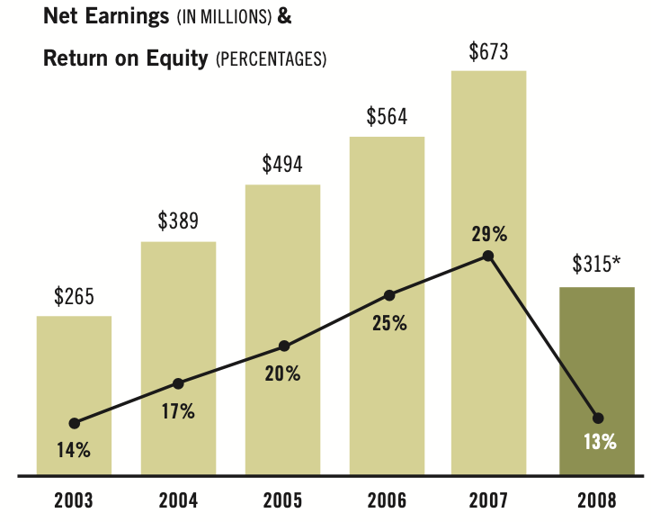

Figure 4. Starbucks' Net Earnings (Schultz, 2008)

Table 1. Competition in the Australian specialty coffee chain market (Patterson et al, 2010)

|  |  |  |  |  |
| --- | --- | --- | --- | --- |
|  | Number of stores | Year established | Price of an coffee | Highlights and lowlights |
| McCafe | 488 | 1993 | Small $3.25 | The fastest growing café brand in Australia and NZ  Number of stores up from 60 in 2002 |
| Starbucks | 23 | 2000 | Tall $3.60 | Prior to closures in August 2008 there was 84 stres |

# **BI REQUIREMENTS**

## **BI requirements for CRM within ERP**

The Business Intelligence (BI) system consists of **four major components: Data Warehouse** – The foundation for storing and managing source data, **Business Analytics** – Tools for analyzing data trends and patterns, **Business Performance Management (BPM) or CRM** – Systems for tracking and optimizing customer interactions and **User Interface (UI)** – Dashboards and tools for end-user interaction (Turban et al, 2008).

The foundational components of enterprise BI architecture are demonstrated in Figures 5 and 6, representing common implementation patterns. Building on these, Figure 7 details the customised architecture designed to address Starbucks' CRM-specific data needs

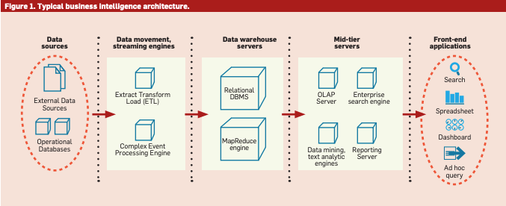

Figure 5. Typical business intelligence architecture. Note (Chaudhuri et al, 2011)

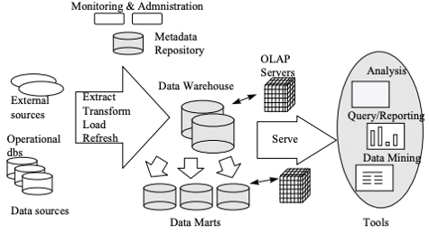

Figure 6. Data Warehousing Architecture. Note (Chaudhuri & Dayal, 1997)

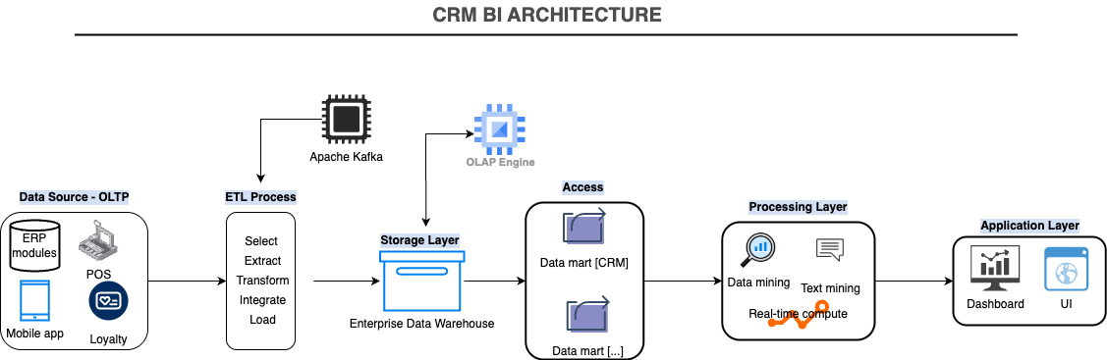

Figure 7. BI's architecture requirements for CRM (Author’s work)

### **Data Sources and Integration Challenges**

Most operational data in **Enterprise Resource Planning (ERP)**and **Customer Relationship Management (CRM)**systems is stored in **OLTP (Online Transaction Processing)** systems, which process user requests in real time (Turban, 2008). However, OLTP systems like **Starbucks’ 2008 CRM** could record transactions but **failed to analyze customer trends across stores**. This limitation highlights the need for a **Modern BI-integrated CRM**combining **OLTP + OLAP (Online Analytical Processing)**with **real-time data warehousing**

The BI framework for Starbucks relies on **diverse data sources**, including:

* **Internal ERP databases** (Sales, HR, Inventory, etc.)
* **External sources** (POS transactions, Loyalty App, Starbucks Mobile App, social media/Feedback)

However, integrating these sources presents challenges:

* **Inconsistent data quality** (missing, duplicate, or outdated entries).
* **Varied formats, codes, and representations** (e.g., different date formats, product IDs).
* **Real-time processing demands** (e.g., streaming customer behaviour for instant insights).

### **ETL Process and Real-Time Data Handling**

Data is prepared for BI tasks using an **ETL (Extract-Transform-Load)** process (Chaudhuri et al, 2011). Increasingly, businesses require **real-time BI**, where decisions are made using live operational data. Technologies like **Apache Kafka** (a distributed event-streaming platform) address challenges such as: Handling **massive data volumes**, ensuring **fault tolerance** (no data loss during system failures) and maintaining **data consistency** across distributed systems (Goswami & Shivaji, 2025)

Furthermore, real-time processing dynamically **monitors resources while also optimising operational expenses** and system performance (Goswami & Shivaji, 2025).

### **Storage Layer: Enterprise Data Warehousing and OLAP**

Processed data is stored in an **Enterprise Data Warehouse (EDW),** which supports **real-time analytics** (Stoica, 2018). From here, **OLAP (Online Analytical Processing)**transforms raw data into actionable insights by: **Roll-up** (increasing aggregation), **Drill-down** (decreasing aggregation), and **Slicing/dicing** (filtering data across dimensions) (Chaudhuri & Dayal, 1997)

A subset of the EDW, the **CRM Data Mart,** focuses exclusively on customer-related data, such as segmented customer profiles and churn risk scores

### **Processing Layer: Analytics and Real-Time Compute**

This layer includes **Analytics Engines** for **Data Mining** (identifying patterns in structured data) and **Text Mining**(analysing unstructured data), and **Real-Time Compute (Flink/Spark)** (updates dashboards with live data (Anveshrithaa & Lavanya, 2020).

### **Application Layer: Visualisation and CRM UI**

Processed data is presented through **Dashboards (Power BI)** for real-time store performance tracking, **Ad-Hoc Query Tools** or **CRM User Interface (UI)**

## **Starbucks and CRM – Specific BI requirements**

### **Customer Segmentation & Personalisation**

Starbucks needs to move beyond generic marketing by identifying high-value customers (frequent buyers, high spenders) and segmenting them based on behaviour (morning versus afternoon visitors). Dynamic personalisation, such as targeted promotions via the Starbucks app, is essential to enhance engagement and loyalty.

### **AI-Driven Product Recommendations**

The CRM must leverage contextual data, such as purchasing history, weather, and location, to suggest relevant products (e.g., food pairings, seasonal drinks). This ensures customers receive timely, personalised offers that align with their preferences.

### **Demand Forecasting & Inventory Optimisation**

An accurate demand forecast is critical to prevent stockouts during peak periods and minimise waste. The CRM should integrate with supply chain systems to enable just-in-time inventory modifications.

### **Customer Retention & Churn Prevention**

Proactively identifying at-risk customers (e.g., declining visit frequency, unused rewards, top negative reviews) and automating retention strategies (e.g., win-back campaigns) will help Starbucks maintain loyalty and reduce attrition (e.g., “We miss you – free drink!”)

# **PROPOSED BI SOLUTION**

For effective Business Analytics, Business Intelligence (BI) relies heavily on data mining. Within the context of Customer Relationship Management (CRM), the primary objective is to establish one-to-one relationships with customers by gaining a deep understanding of their needs and preferences. Over time, as businesses like Starbucks interact with customers through product inquiries, purchases, service feedback, and loyalty programs, they accumulate massive volumes of data. When combined with demographic and socioeconomic attributes, this data becomes a powerful resource that can be mined to identify likely buyers of new products or services (customer profiling), understand the causes of customer churn to improve retention, discover time-sensitive patterns in product associations to enhance sales strategies, and pinpoint the most profitable customer segments to tailor offerings more effectively (Turban, 2008)

Data mining – the extraction of predictive insights from large data sets – is a powerful BI technique. It enables businesses to uncover hidden patterns that may not be obvious even to domain experts, as it surpasses human expectations and reveals connections and trends that can be pivotal for strategic decision-making. According to the referenced literature, data mining operates within the data warehouse environment to reveal these predictive insights at scale (Pujari, 2001)

In parallel, text mining, also known as knowledge discovery in textual databases, has become indispensable for CRM. As Starbucks customers increasingly engage through reviews, social media posts, and in-app messages, vast amounts of unstructured text data are generated. Text mining allows for the semi-automated extraction of meaningful patterns from these sources. When combined with structured customer data, it enables companies to forecast customer sentiments, understand consumer perceptions, and anticipate future purchasing behaviour (Turban, 2008).

## **Customer segmentation & Personalisation**

Data mining techniques such as K-means clustering can be employed to segment customers based on purchasing behaviour. For example, by analysing recency, frequency, and monetary (RFM) metrics, Starbucks can distinguish between occasional buyers and loyal customers. Further segmentation can be achieved by identifying patterns such as time-of-day purchases—like “morning commuters” or product preferences. Additionally, association rule mining can be used to identify product affinities, such as customers who frequently buy coffee and cakes together. On the unstructured data side, text mining tools like sentiment analysis help classify customers by emotional tone, such as distinguishing “price-sensitive” individuals from “quality-focused” ones. Topic modelling can surface themes in customer feedback, such as recurring mentions of dairy-free alternatives. These insights support Starbucks in replacing generic promotions with highly personalised marketing efforts—for instance, offering oat milk discounts to health-conscious consumers or delivering a 7 AM breakfast bundle deal.

## **AI-Driven Product Recommendation**

Through collaborative filtering (Machine learning – Deep Learning NCF, K-Nearest Neighbours k-NN), Starbucks can offer recommendations by analysing similarities in user behaviour. Contextual rules can enhance these systems by integrating real-world variables, for instance, suggesting hot beverages on cold days with temperatures below 20°C. Natural language processing (NLP) applied to text data from reviews and social media posts can reveal trending ingredients like “matcha”, while intent detection in app conversations helps identify customers eager for new flavour sensations. By offering relevant, real-time suggestions, Starbucks can increase the average order value, such as prompting a cold brew drinker to try a new matcha sweet cream cold foam option.

## **Demand Forecasting & Inventory Optimisation**

In the domain of demand forecasting and inventory optimisation, time-series forecasting models such as ARIMA, Prophet and LSTM enable Starbucks to foresee demand surges associated with holidays or seasonal events. Anomaly detection techniques can highlight unexpected demand spikes, such as viral TikTok-inspired drinks. Text mining further supports this process through social media monitoring, which can detect early signs of rising trends. Furthermore, customer reviews complaining about frequent stockouts can cause forecast adjustments. By combining these structured and unstructured insights, Starbucks can reduce product waste and stockouts, for example, by increasing syrup inventory in regions where online searches for “matcha” are trending.

## **Customer Retention & Churn Prevention**

Data mining models like logistic regression can flag customers who show indicators of disengagement, such as reduced visit frequency or unredeemed rewards points. Survival analysis can further estimate the expected time until churn occurs, particularly across different loyalty tiers. Text mining enables the identification of churn drivers through topic modelling of complaints (NLP), revealing whether customers are leaving due to price increases or service delays. Sentiment analysis tools can generate real-time alerts when negative feedback is detected, allowing Starbucks to respond quickly. For example, if a customer tweets, “Starbucks prices are too high,” the system could automatically send a personalised discount to retain the customer, contributing to an overall reduction in churn.

# **DATA DASHBOARD**

The following PowerBI dashboards demonstrate the primary characteristics to encourage the CRM of Starbucks to address its challenge in 2008

## **Customer Segmentation & Personalisation**

This interactive Power BI dashboard offers a comprehensive analysis of Starbucks' customer base, enabling data-driven marketing and operational decisions. Firstly, the cards highlighted the number of loyal and total customers that day (so that we could determine the number of occasional customers) as well as the number of the day’s most ordered drinks. The dashboard organises customers by key demographic criteria, including age groups, gender, income levels, and occupation, allowing managers to quickly identify high-value segments by utilising Power BI’s parameters and slicer. Interactive filters enable users to investigate how different customer groups behave, such as comparing visit frequency between millennials (20-29 years) and older demographics (40+ years). Time-based analytics track purchasing trends by hour, revealing that professionals predominantly buy coffee before 9 AM, while students and workers prefer afternoon snacks. The dashboard's drill-down capability allows store managers to uncover product affinities, such as types of demographics for purchase items, supporting targeted inventory planning and staffing adjustments. Real-time data integration ensures recommendations reflect current purchasing behaviours rather than historical averages

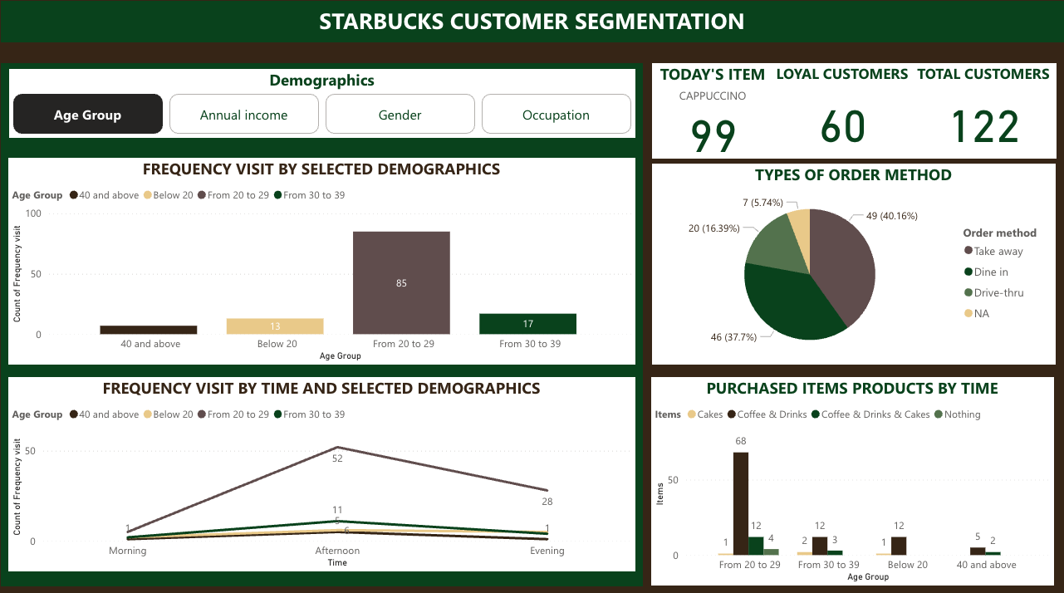

Figure 8. Starbucks Customer Segmentation Dashboard (Author’s work)

## **AI-Driven Product Recommendation**

This dashboard employs machine learning to deliver personalised drink and food suggestions, enhancing customer experience while increasing sales. By analysing individual purchase histories, the system builds extensive customer profiles – for example, identifying that a particular customer (ID 1139)’s favourite drink is coffee based on their frequency. The AI model incorporates contextual data like real-time weather, automatically suggesting hot beverages during cold days, like a cappuccino. The interface prominently highlights trending items, with visual indicators showing which recommendations have the highest accuracy scores based on past behaviour. Additionally, it also includes the WorldCloud for trending ingredients that customers are currently discussing, like matcha or chocolate mint. Managers can track the performance of these suggestions using redemption rates, allowing continuous refinement of the algorithm. Integration with Starbucks' mobile app enables these personalised recommendations to appear at the point of order, eliminating customer decision fatigue. The dashboard also includes a top 10 most recommended items that the AI generated by the top-most ordered items in the same condition in the past, and based on the trending drinks, it has generated

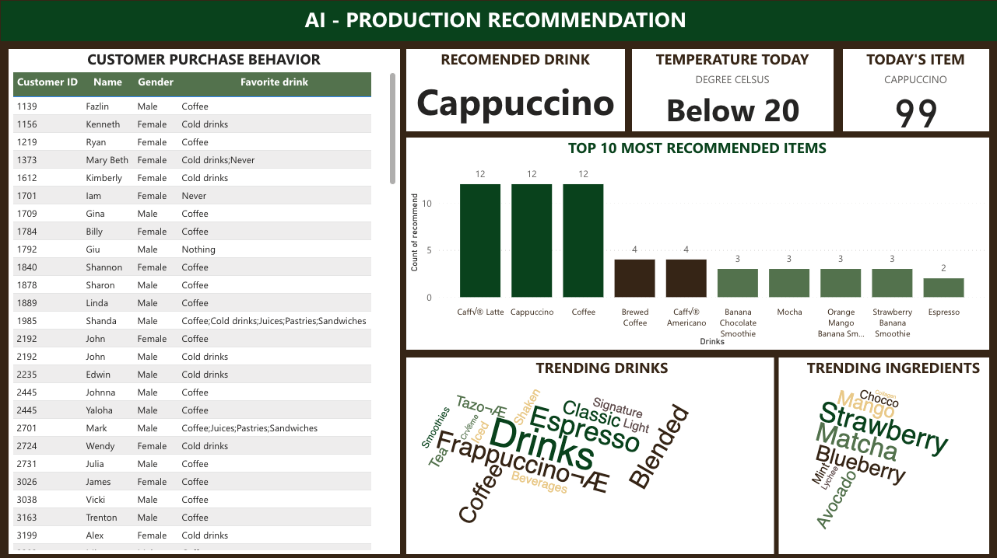

Figure 9. Starbucks' AI Product Recommendation Dashboard (Author’s work)

## **Customer Retention & Churn Analysis**

This interactive Power BI dashboard provides a comprehensive view of customer loyalty and churn threats. It prominently displays the current retention rate, calculated as the ratio of active loyal customers this month to Starbucks' total loyalty program members. It identifies at-risk customers (those with no recent orders) and triggers automated free drink offers (according to their historical preferences) to incentivise re-engagement. Real-time customer feedback is integrated via a sentiment analysis feature that processes app reviews and surveys, highlighting the day's most reacted-to comments with NLP. The dashboard includes dynamic rating metrics across key parameters (price, quality, service, WiFi) via slicers, while a concerning trend emerges in the rating distribution pie chart where 1-star reviews dominate, signalling urgent improvement areas. A secondary pie chart breaks down customer retention distribution, enabling quick segmentation of loyal versus at-risk groups. Together, these visualisations create an actionable early-warning system for customer retention efforts.

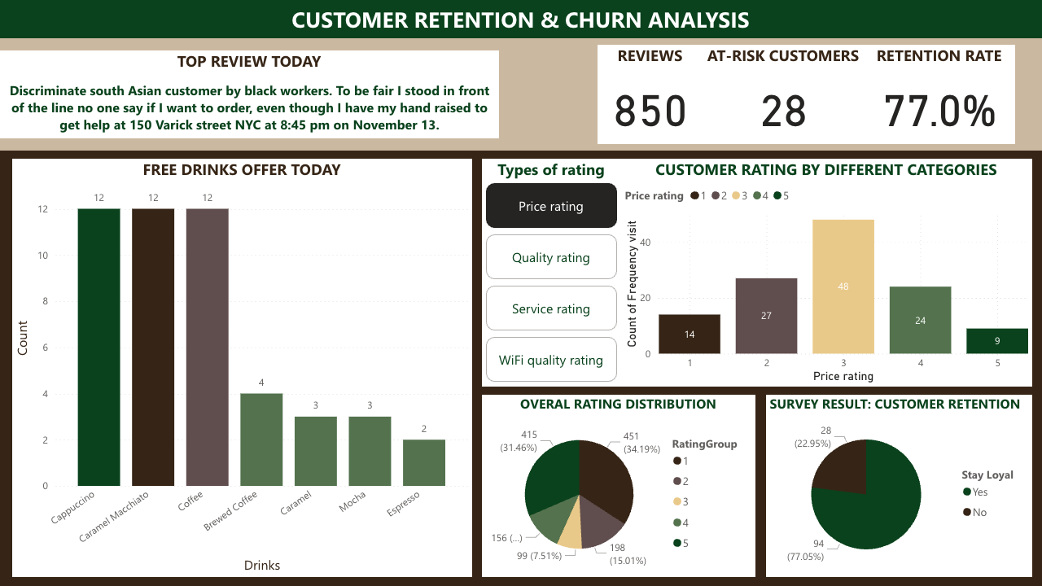

Figure 10. Starbucks' Customer Retention & Churn Analysis (Author’s work)

# **DISCUSSION AND CONCLUSION**

## **The ethical considerations**

### Data Privacy & Consent

The collection of detailed customer data—including purchase history, location tracking, and app behaviour—poses significant privacy risks if not managed responsibly. Under regulations like the **GDPR**and **CCPA (Mallet & Hamdan, 2025),** Starbucks must ensure transparency in how this data is used for profiling and personalisation. A key risk is that customers may be unaware of how their information fuels recommendation algorithms or targeted marketing. To mitigate this, Starbucks should implement **explicit opt-in consent** mechanisms, clearly explaining data usage in simple language (e.g., “We analyse your past orders to suggest drinks you might like”). Customers should be able to **disable tracking** or erase their data upon request. A**nonymisation and aggregation** techniques can reduce privacy concerns. Finally, **to optimise BI,** only essential data (e.g., order frequency) should be stored rather than payment details

### Algorithm Bias & Fairness

Machine learning algorithms used for recommendations or churn prediction may **perpetuate biases**. For instance, if training data overrepresents certain demographics, the AI might underperform for others. To address this, Starbucks must **audit algorithms regularly** for discriminatory patterns and **diversify datasets** to reflect all customer demographics. Transparency is critical: customers should receive **plain-language explanations** for AI-driven suggestions (e.g., “You’re seeing this because customers like you enjoyed it”).

### Environmental Sustainability

BI systems’ computing demands, especially real-time analytics and ML model training, can have a **high carbon footprint**. Starbucks should adopt **green BI practices (Sun et al, 2020)**, such as installing models in **carbon-neutral cloud regions** and optimising algorithms to reduce redundant computations. Energy-efficient infrastructure choices, like serverless analytics, can further reduce environmental impact

## **The design principles behind an efficient data dashboard**

An effective dashboard design must balance visual appeal with functionality, assuring clarity, consistency, and usability while aligning with Starbucks' brand identity through its signature green and white colour scheme, high-contrast visuals, and clear typography. The layout should emphasise hierarchy, highlighting key metrics like customer churn or loyalty performance through strategic placement, larger fonts, or accent colours, while remaining minimal to avoid clutter through logical grouping and interactive elements like filters and drill-downs. Above all, the dashboard must prioritise data accuracy through rigorous cleaning and validation, ensuring insights are reliable and actionable, ultimately guiding stakeholders toward informed decisions with an intuitive, brand-cohesive, and user-friendly interface.

## **Conclusion – Main point from the report**

In conclusion, this report demonstrates how Business Intelligence (BI) can transform Starbucks' Customer Relationship Management (CRM) by enabling data-driven decision-making via sophisticated analytics, real-time insights, and predictive modelling. By implementing a robust BI architecture—including optimised data warehouses, AI-powered recommendation systems, and interactive dashboards—Starbucks can enhance customer personalisation, retention strategies, and operational efficiency. Ethical considerations around data privacy, algorithmic fairness, and sustainability ensure responsible deployment, while effective dashboard design principles guarantee clarity and actionability. Finally, integrating BI with Starbucks' existing ERP system provides strategic advantages, turning customer data into meaningful business value and sustaining its competitive edge in the retail coffee industry.

# **APPENDIX**

[**https://uoneduau-my.sharepoint.com/:u:/r/personal/c3425175_uon_edu_au/Documents/BUSA3002/assessment/Starbucks%20dashboard.pbix?csf=1&web=1&e=D51yGO**](https://uoneduau-my.sharepoint.com/:u:/r/personal/c3425175_uon_edu_au/Documents/BUSA3002/assessment/Starbucks%20dashboard.pbix?csf=1&web=1&e=D51yGO)

# **REFERENCE**

Ali, M., & Miller, L. (2017). ERP system implementation in large enterprises – a systematic literature review. *Journal of Enterprise Information Management*, *30*(4), 666–692. [https://doi.org/10.1108/JEIM-07-2014-0071](https://www.emerald.com/insight/content/doi/10.1108/jeim-07-2014-0071/full/html)

Anveshrithaa, S., & Lavanya, K. (2020). Real-Time Vehicle Traffic Analysis using Long Short Term Memory Networks in Apache Spark. *2020 International Conference on Emerging Trends in Information Technology and Engineering (Ic-ETITE)*, 1–5. <https://doi.org/10.1109/ic-ETITE47903.2020.97>

Barney, N., Hashemi-Pour, C., & Chai, W. (2023, October). *What is CRM (customer relationship management)?* TechTarget. <https://www.techtarget.com/searchcustomerexperience/definition/CRM-customer-relationship-management>

Chaudhuri, S., & Dayal, U. (1997). An overview of data warehousing and OLAP technology. *ACM SIGMOD Record*, *26*(1), 65–74. [https://doi.org/10.1145/248603.248616](https://dl.acm.org/doi/10.1145/248603.248616)

Chaudhuri, S., Dayal, U., & Narasayya, V. (2011). An overview of business intelligence technology. In *Communications of the ACM* (Vol. 54, Number 8, pp. 88–98). Association for Computing Machinery (ACM). [https://doi.org/10.1145/1978542.1978562](https://dl.acm.org/doi/10.1145/1978542.1978562)

Goswami, A., & Shivaji, G. B. (2025). Using Big Data and Kafka to Track Resource Utilization in Real Time. *2025 International Conference on Intelligent Control, Computing and Communications (IC3)*, 1028–1034. <https://doi.org/10.1109/IC363308.2025.10957433>

Gulbinovic, C. (2015, August 24). *Difference between Old and New CRM | Teamgate Blog*. Teamgate. [https://www.teamgate.com/blog/old-vs-new-crm/](https://www.teamgate.com/blog/old-vs-new-crm/#:~:text=Traditional%20CRM%20is%20typically%20an,and%20more%20user%2Dfriendly%20interfaces)

Habul, A., & Pilav-Velic, A. (2010). Business intelligence and customer relationship management. *Proceedings of the ITI 2010, 32nd International Conference on Information Technology Interfaces*, 169–174. <https://ieeexplore-ieee-org.ezproxy.newcastle.edu.au/document/5546381>

Husain, S., Khan, F., & Mirza, W. (2014, September 28). *How Starbucks pulled itself out of the 2008 financial meltdown*. Business Today. <https://www.businesstoday.in/magazine/lbs-case-study/story/how-starbucks-survived-the-financial-meltdown-of-2008-136126-2014-09-22>

Leapify. (2024, October 30). *Predictive AI vs Traditional CRM | Leapify*. Leapify.com. <https://leapify.com/blog/predictive-ai-vs-traditional-crm>

Mallet, P., & Hamdan, R. K. (2025). Comparative Analysis of Data Privacy Legislation: Convergence and Divergence Between the GDPR and CCPA. In *Tech Fusion in Business and Society* (pp. 465–475). Springer Nature Switzerland. <https://doi.org/10.1007/978-3-031-84636-6_40>

Maverick, M. (2024). *The Complete Marketing Case Study on Starbucks*. Marketing Maverick. <https://marketingmaverick.io/p/the-marketing-case-study-on-starbucks>

McCue, I. (2023, May 29). *What is ERP (Enterprise Resource Planning)?* Netsuite. <https://www.netsuite.com.au/portal/au/resource/articles/erp/what-is-erp.shtml>

Patterson, P. G., Scott, J., & Uncles, M. D. (2010). How the local competition defeated a global brand: The case of Starbucks. *Australasian Marketing Journal*, *18*(1), 41–47. [https://doi.org/10.1016/j.ausmj.2009.10.001](https://journals.sagepub.com/doi/10.1016/j.ausmj.2009.10.001)

Pujari, A. K. (2001). *Data mining techniques*. Universities press. <https://books.google.com.au/books?hl=vi&lr=&id=dH2KQhJboSYC&oi=fnd&pg=PR11&dq=data+mining&ots=zN1Ed55PGc&sig=4PkpNSHyv2a8WIKKv2gPUFLXdC0#v=onepage&q&f=false>

Sardjono, W., Kristin, D. M., & Putra, G. R. (2023). Model of Customer Relationship Management Systems Evaluation Using Factor Analysis. *2023 International Conference on Information Management and Technology (ICIMTech)*, 784–788. [https://doi.org/10.1109/ICIMTech59029.2023.10277947](https://ieeexplore.ieee.org/document/10277947)

Schultz, H. (2008). *Starbucks Corporation Fiscal 2008 Annual Report*. <https://s203.q4cdn.com/326826266/files/doc_financials/SBUX2008ARv5_2008.pdf>

*Starbucks’ Customer Management Case Study - GWO SEVO*. (2024, February 19). GWO SEVO. <https://gwosevo.com/starbucks-customer-management-case-study/>

Stoica, L. C. (2018). Business intelligence and olap. Knowledge Horizons. Economics, 10(3), 68-76. <https://orizonturi.ucdc.ro/arhiva/KHE%20nr.%203%20-%202018/9.%20BUSINESS%20%20INTELLIGENCE%20AND%20%20OLAP.pdf>

Subham Kumar R. (2023, May 20). *What are the common challenges in customer relationship management? Customer relationship management (CRM) is a crucial aspect of any business, but it is not without its challenges. The five main challenges in CRM are high cost, insufficient time, bad data quality, lack of communication, and limited*. Linkedin.com. <https://www.linkedin.com/pulse/challenges-customer-relationship-management-subham-kumar-rai/>

Sun, Y., Bi, K., & Yin, S. (2020). Measuring and Integrating Risk Management into Green Innovation Practices for Green Manufacturing under the Global Value Chain. *Sustainability*, *12*(2), 545-. [https://doi.org/10.3390/su12020545](Sun,%20Y.,%20Bi,%20K.,%20&%20Yin,%20S.%20(2020).%20Measuring%20and%20Integrating%20Risk%20Management%20into%20Green%20Innovation%20Practices%20for%20Green%20Manufacturing%20under%20the%20Global%20Value%20Chain.%20Sustainability,%2012(2),%20545-.%20https:/doi.org/10.3390/su12020545)

Themistocleous, M., Rosemann, M., & Loos, P. (2005). *Enterprise Resource Planning And Enterprise Application Integration* (1st ed., Vols. 18, 4). Emerald Publishing Limited. <https://ebookcentral.proquest.com/lib/newcastle/detail.action?docID=253985>

Tucker, B. (2024, September 9). *Traditional CRMs are Killing Your Sales Team’s Productivity*. Sales & Marketing Management. <https://salesandmarketing.com/traditional-crms-are-killing-your-sales-teams-productivity/>

Turban, E., Sharda, R., Aronson, J. E., & King, D. (2008). Business Intelligence: A Managerial Approach. Upper Saddle River, NJ: Pearson Prentice Hall. <https://davidhason.com/wp-content/uploads/2024/05/Business-Intelligence_-A-Managerial-Approach.pdf>